**CREATE AND CONFIGURE IBM CLOUD SERVICES**

Create NODE-RED Service

|  |  |
| --- | --- |
| Team ID | PNT2022MID21348 |
| Project Name | Smart Waste Management System For Metropolitan City |

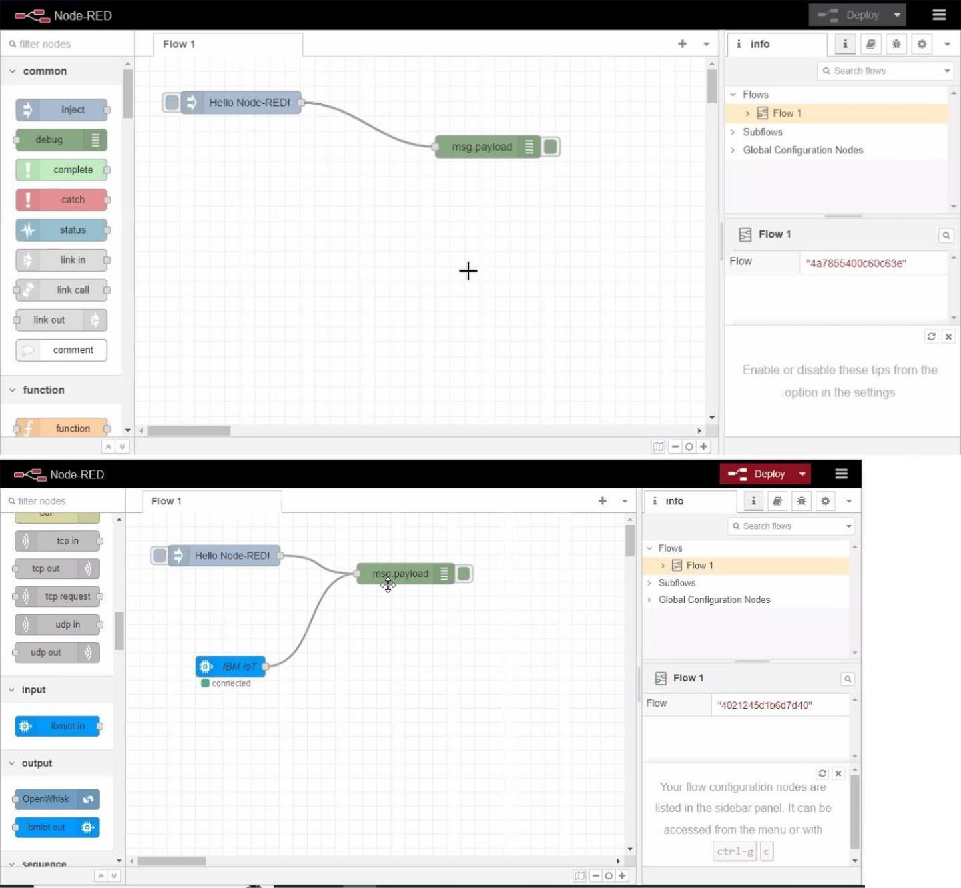

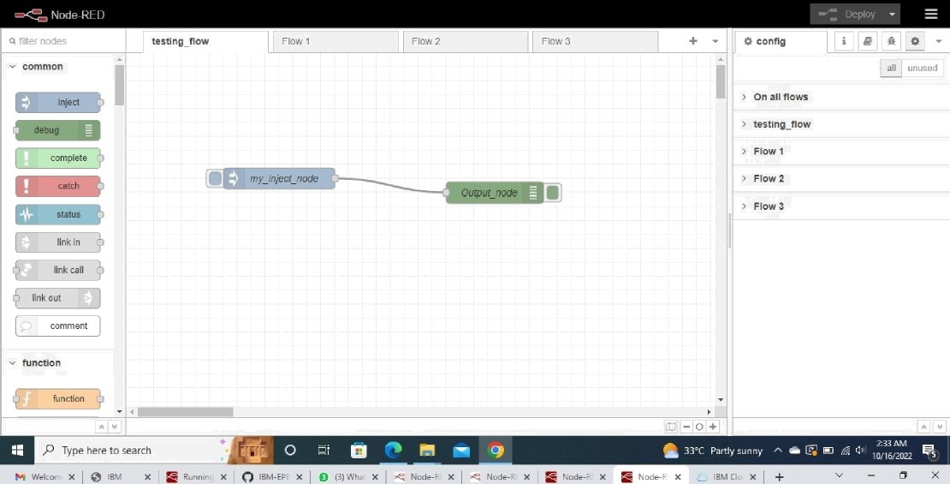.

.

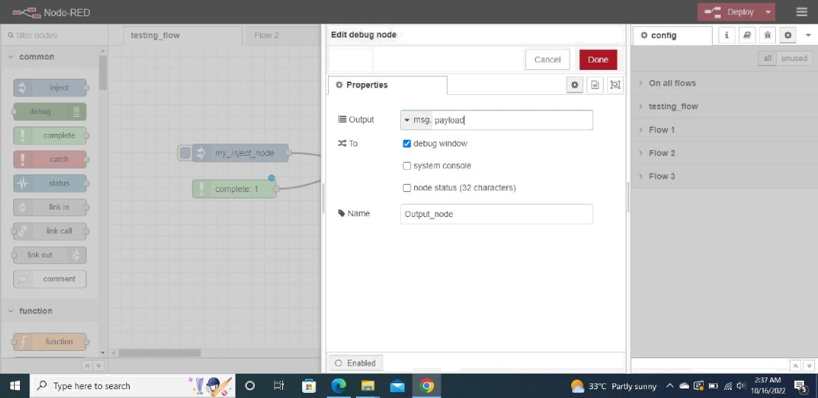

Delete